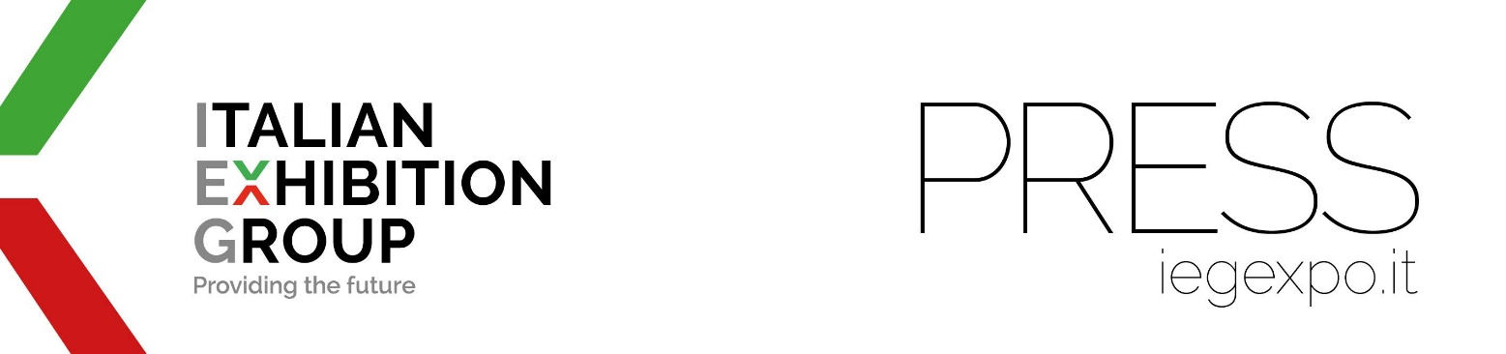

press release
(English translation)

IEG ESTABLISHES IEG ASIA IN SINGAPORE, APPOINTING ILARIA CICERO AS CEO,
AND FINALISES THE ACQUISITION OF TWO NEW TRADE FAIRS
FOR JEWELLERY AND FOOD & BEVERAGE

- Following the signing of the Memorandum of Understanding (“MOU”) between Italian Exhibition Group (IEG) and the Singapore Tourism Board on 5th October 2022, IEG has established “IEG Asia Pte. Ltd.” in Singapore, continuing, with the support of the Singapore Tourism Board (STB), its development plan in Southeast Asia.
- IEG finalised yesterday the acquisition of two CEMS - Conference & Exhibition Management Services business areas related to Sije - Singapore International Jewelry Expo and Café Restaurant Asia.
- Statements from IEG International Business Development Director, Francesco Santa, Ilaria Cicero, CEO of IEG Asia, CEMS founder, Mr. Edward Liu, and STB Executive Director for Exhibitions and Conferences, Mr. Poh Chi Chuan.

Rimini, 28th February 2023- Just a few months after signing of the MOU, ITALIAN EXHIBITION GROUP (IEG) has made a definitive landing in Singapore with its own company “IEG Asia Pte. Ltd.”, an entirely owned subsidiary, and with two trade show events in the jewellery and food & beverage sectors respectively, acquired from CEMS - Conference & Exhibition Management Services: to be precise, Sije - Singapore International Jewelry Expo and Café and Restaurant Asia.
With this operation, IEG, organiser of Vicenzaoro and Sigep, leading events held in Italy in the jewellery and food sectors, is continuing its expansion strategy into Southeast Asia, starting from Singapore - considered the hub par excellence, both from a logistic and economic point of view - to once again trigger that virtuous circle that, moving from the Rimini and Vicenza areas, strengthens the business of companies at a global level for further spin-off in the territories of origin.
Singapore Tourism Board confirms its support for IEG and IEG Asia in the development of existing events and the launch of new projects that can further strengthen the entire MICE (Meetings, Incentives, Conferences and Exhibitions) ecosystem in Singapore.

DECLARATIONS
“First and foremost,” says Francesco Santa, International Business Development Director at IEG, “we are delighted to confirm the partnership with STB, a guarantee of development and success for the acquired exhibitions. We would also like to emphasise how important synergies between events in Italy and those acquired are, not to mention the consequent impact generated by internationalising our exhibitions on Italian territory.”

According to Ilaria Cicero, CEO of IEG Asia: “The aim is to develop the shows in Singapore, also by leveraging on a mutual, productive exchange of the enormous success of the last edition of Vicenzaoro in January 2023, which was attended by over 1.300 exhibiting brands. The same can be said for Sigep with 1.000 companies exhibiting at the 2023 edition in Rimini”.

“With the dawn of the Aseanisation of the MICE industry in Southeast Asia in this decade,” says Edward Liu - Managing Director, Conference & Exhibition Management Services Pte Ltd - “and the goals of bringing our events to the next level for Singapore and the region, we are delighted to tie up with the Italian Exhibition Group, which owns the Sigep and the Vicenza Jewellery Shows in Italy and abroad. These signature events would certainly complement our portfolio of the Café and Restaurant Asia series as well as the Singapore International Jewellery Expo (SiJE). IEG ‘s strategic plan to expand into the Asia region will enhance our current shows to grow at a faster pace to meet the needs of the Asian market, and this would augur well for the MICE industry in Singapore and beyond in the near future.”

Poh Chi Chuan, Executive Director, Exhibitions and Conferences, Singapore Tourism Board, says: "We warmly welcome IEG’s increased presence in Singapore and their plans to anchor renowned global events here. IEG’s plans, as well as the recent opening of its regional headquarters in Singapore, underscore how our MICE industry is firmly on the recovery trajectory. We look forward to working together to bring in new tradeshows across other sectors as global business travel picks up pace.”

IEG IN ASIA
IEG is already active in Asia with international brands: in the Arab Emirates with Dubai Muscle & Active Show, the Middle East’s leading fitness and body building exhibition, and with JGT in Dubai, one of the world’s most prominent jewellery trade shows; in the People’s Republic of China with CDEPE - Chengdu International Environmental Protection Expo, a major trade show for green technologies, and with Sigep China (organised by IEG China, IEG Group company), the show dedicated to gelato, pastry, bakery and coffee, that will be making its debut in 2023 from 10th to 12th May in Shenzhen, in partnership with Koelnmesse.

PRESS CONTACT ITALIAN EXHIBITION GROUP media@iegexpo.it
Elisabetta Vitali, head of corporate communication and media relation;
Silvia Giorgi, international press office manager

This press release contains forecast elements and estimates that reflect the management’s current opinions (“forward-looking statements”), particularly regarding future management performance, realization of investments, cash flow trends and the evolution of the financial structure. For their very nature, forward-looking statements have a component of risk and uncertainty, as they depend on the occurrence of future events. The effective results may differ (even significantly) from those announced, due to numerous factors, including, only by way of example: food service market and tourist flow trends in Italy, gold and jewellery market trends, green economy market trends; the evolution of raw material prices; general macroeconomic conditions; geopolitical factors and evolutions in the legislative framework. Moreover, the information contained in this release does not claim to be complete, and has not been verified by independent third parties. Forecasts, estimates and objectives contained herein are based on the information available to the Company as at the date of this release.

